Introduction
Genetibase NuGenObjective is a new method of visualizing systems. A NuGenObjective diagram can be used to represent the entities in a system, the states that these entities are in, and the interaction of people external to the system with these entities.
As an example, let us consider the direct sales departments of an organization. Quotations may be requested by customers or partners. They would be prepared by sales executives, approved by sales managers, and sent to the customer or partner by the sales executives again. Such a system would be modeled as follows using NuGenObjective.
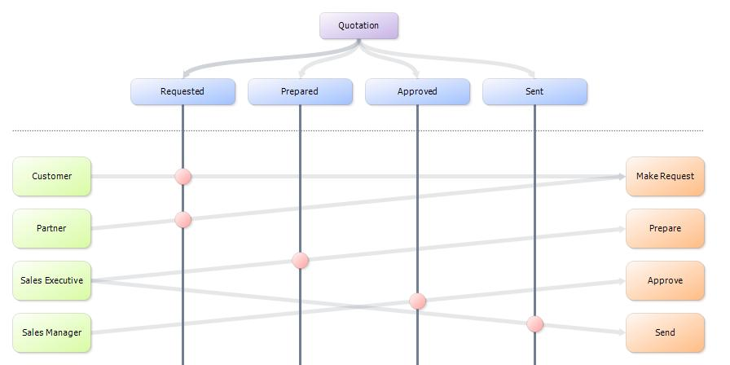
The NuGenObjective Diagram designer allows users to draw and save NuGenObjective diagrams. It also allows publishing of diagrams to the NuGenObjective server, and multi-user editing of published diagrams.
The NuGenObjective server allows central storage for shared diagrams, and co-operative multi-user editing. It also provides a browser-based interface for viewing shared diagrams.

Concepts

System
A NuGenObjective system is a model of a system in the real world, according to the rules defined in the rest of this section. It consists of Objects, States, Roles, Actions and Interactions.

Object
A NuGenObjective model object is a representation of an entity in the real world. Objects could be business entities such as Purchase Order, physical entities such as a RFP document, or system components such as Data Access Layer Module (as part of a software development project). The purpose of a NuGenObjective system is to model the fact that objects transition from state to state, as a result of actions initiated by people.

State
A NuGenObjective model state is a representation of a state in the real world. NuGenObjective states can exist independent of objects; i.e., a state may be applied to a single object, multiple objects, or no object; and an object may transition to any number of states.

Role
A NuGenObjective role represents a class of people, internal or external to the system, which is allowed to interact with objects in the system. Roles, like states, are independent; a role can interact with as many objects as necessary. A role interacts with an object through an action, via an interaction.

Action
A NuGenObjective action represents a class of activity that can be performed on one or more objects. Like states and roles, actions exist independent of any object; an action may be applied to any number of objects.

Interaction
A NuGenObjective interaction models a real world activity (modeled as a NuGenObjective action) taken by a known class of people (modeled as a NuGenObjective role), which causes an object to transition into a state. Interactions are specific to objects in a NuGenObjective system; i.e., each object has its own set of interactions. Apart from the object, each interaction is associated with one Role, one Action, and one State.

Diagram
A NuGenObjective diagram is the visual representation of a NuGenObjective system. It displays the components of a system on one or more pages. A diagram may be saved in a file on local or network storage, and also may be published to a NuGenObjective server.
Each page in a diagram can represent the whole system, or any subset thereof. Any component of the system may appear on multiple pages, or not be shown at all.

Shared Diagram
A NuGenObjective shared diagram is a diagram that has been published to a NuGenObjective server. A shared diagram may be edited when a client is connected to the NuGenObjective server. A shared diagram may also be saved in a file on local or network storage for offline viewing. In any case, a shared diagram maintains a relationship with the server that it was originally published to, and can be edited only if the client has connectivity to that server.

Drawing Diagrams

The NuGenObjective Diagram Designer
Diagrams are drawn using the NuGenObjective diagram designer. The screenshot below shows the diagram designer user interface.
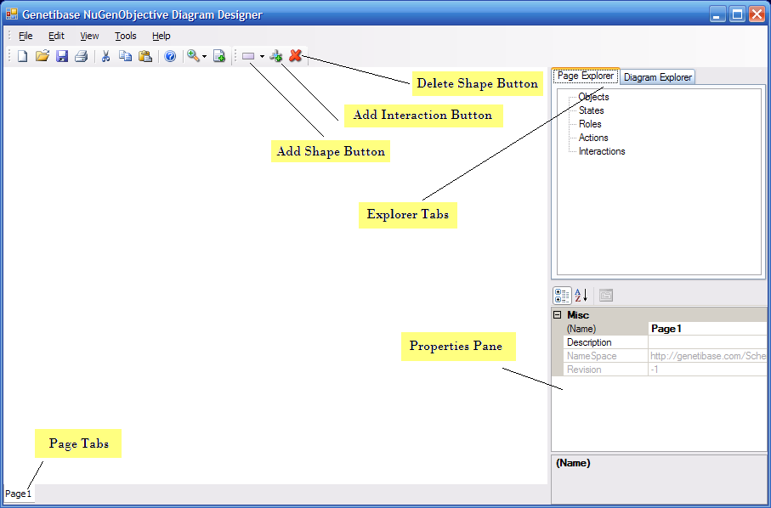

Adding Objects, States, Roles and Actions to the Diagram
These shapes can be added to the diagram using the Add Shape button. The drop-down arrow next to the button opens a menu containing available shapes, as shown below:
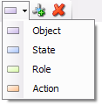
Clicking a shape adds it to the diagram. The Add Shape button displays the last shape that was added. If the same shape is to be added again, the button can be clicked directly.
When a shape is added to a diagram, it is also added to the current page. It may subsequently be added to more pages, deleted from pages, or deleted from the diagram altogether.
When a shape is added to the diagram, it is given a default name. This may be changed later.

Adding Interactions to the diagram
A NuGenObjective Interaction is an Action initiated by a Role, which puts an Object into a State. So, before adding an interaction, the associated Role, Action, State and Object have to be created.
To add an interaction to a diagram, the associated Object has to be selected first. Clicking the Add Interaction button then brings up the following dialog:
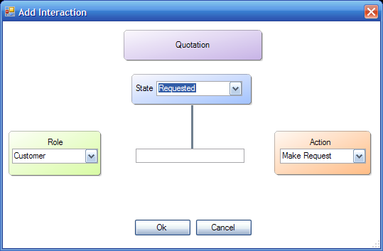
Here, the associated State, Role and Action may be chosen, and a name given to the Interaction.

Editing Properties
Once a shape has been added to a page, its properties may be edited by selecting the shape and changing the properties in the Properties pane. For any shape other than Interaction, the name can be changed directly by selecting the shape and pressing F2.
Note that only one shape may be selected at a time.

Scrolling a page
If a diagram becomes too big to fit on a visible page, scroll arrows automatically appear at the page boundaries. These may be clicked to scroll the page. Alternatively, dragging any empty area on the page will cause it to be scrolled.

Adding New Pages
A new page may be added by clicking the Add Page button on the toolbar. The pages appear on the Page tabs at the bottom of the window. The name of a page can be changed using the Properties pane. Clicking a page tab selects the page and displays it. Or clicking any empty area on a page displays the properties of the page in the Properties pane.

Using the Page Explorer
The Page Explorer displays the shapes that have been added on the current page. Clicking a shape in the page explorer selects it on the diagram, and displays its properties in the Properties pane.

Using the Diagram Explorer
The Diagram Explorer displays all the shapes that have been added on any page in the diagram. Even if a shape has been added to more than one page, it will show up once in the diagram explorer.
To add an existing shape to another page, select the target page, and double-click the shape in the Diagram Explorer.

Zooming the Page
The Zoom button can be used to make the visible page larger or smaller for viewing.

Working with NuGenObjective Server
The NuGenObjective server allows central storage of diagrams, and allows multiple users to edit a diagram collaboratively. The NuGenObjective server is a web-based server system, whose URL should be known to users.

Publishing Diagrams
A diagram can be published to a NuGenObjective server. Once a diagram has been published, the copy on the server should be treated as the authoritative copy. The local copy continues to exist independently, but should not be edited thereafter.
To publish a diagram, the Publish to Server command from the File menu should be used. This brings up the following dialog:
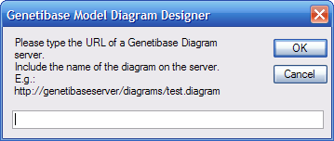
The URL of the NuGenObjective server, along with the full name of the diagram, should be provided. This will publish the diagram to the server. At this point, the user is still working on the original, local copy.

Working with Shared Diagrams

Opening a Shared Diagram from the Server
To begin working with a Shared Diagram, choose the Open from Server command from the File menu. The following diagram appears:
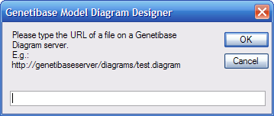
The URL of the NuGenObjective server, along with the full name of the diagram, should be provided. At this point, the diagram will be opened from the server. The Server menu will become available. The Server menu looks as follows:
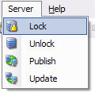

Locking/Unlocking the Shared Diagram
When a shared diagram is first opened, it cannot be edited. To edit it, it has to be locked on the server. This prevents two users from updating the diagram at the same time.
To lock a diagram, the Lock command from the Server menu has to be used. If a diagram has already been locked by another user, it cannot be locked. Otherwise, a lock is placed on the diagram on the server, and the user can edit the diagram.
Once the edit is over, the user should unlock the diagram, using the Unlock command of the Server menu. This will publish the changes made to the diagram back to the server, and unlock it such that other users may edit it as needed.
When a user attempts to lock a diagram, it is possible that the version on the server is later than the offline version on that user’s machine. In the process of obtaining a lock, the user’s copy diagram is updated to the latest version.
If a lock is obtained on a diagram, and no activity is performed on it for five minutes, the lock is automatically released.

Saving a Shared Diagram for Offline Viewing
A shared diagram may be saved for offline viewing, using the Save command from the File menu. This will save changes locally, but not update the diagram on the server.

Re-publishing
The Publish command of the Server menu re-publishes the diagram to the server, and keeps the lock on the diagram.

Updating the local copy to the latest version
Sometime, the copy of the diagram on the server may change while a user is viewing her local copy. The Update command of the Server menu gets the latest version of the diagram from the server, without obtaining a lock on it.

